Mediroza General Hospital – Penetration Testing Report

Field | Details
Tester | MYRA ALI KHAN
Program / Batch | B083D– Networkwalks Cybersecurity Internship, Week 4
Client | Mediroza General Hospital
Target | https://medirozahospital.com
Engagement type | Full black-box penetration test
Date of testing | 3 October 2026
Authorization | Written authorisation provided by Networkwalks for this training environment
Scope | Target domain only. No social engineering, no denial of service, no testing outside the agreed scope.
This assessment was conducted in a controlled Networkwalks training environment. The techniques shown must never be used against any system without explicit written permission from its owner.

1. Executive Summary
The Mediroza web application is critically vulnerable. Starting with no credentials, I bypassed the patient login using SQL injection, downloaded confidential patient reports, cracked their weak encryption, and followed a clue in a PDF's metadata to a forgotten database backup left exposed in a public folder. That backup contained the salaries of all 30 staff and the hospital's full shareholder register in plain text.
The root problem is a chain of small failures that compound: input is not sanitised, files are weakly protected, metadata is not stripped, and an old backup was left world-readable. Any one is serious; together they expose the hospital's most sensitive data to an anonymous attacker.
Seven findings are recorded below, three rated Critical. The highest priorities are fixing the SQL injection (finding 2) and removing the exposed backup (findings 6 and 7).

2. Scope & Methodology
Target: https://medirozahospital.com, web application and reachable files only. Testing stayed within the authorised scope: no social engineering, no denial of service, no activity outside the target domain.
Approach: a black-box test with no prior credentials or knowledge, working through four milestones, reconnaissance and initial access, data extraction, deep reconnaissance, and reporting.
Tools used: curl and wget (recon and downloads); a browser (login testing); the Networkwalks Hash Calculator and Password Cracker, and John the Ripper with the rockyou wordlist (PDF cracking); qpdf (PDF decryption); exiftool (metadata analysis). All work was done from Kali Linux.
The diagram below shows how one weakness led to the next.
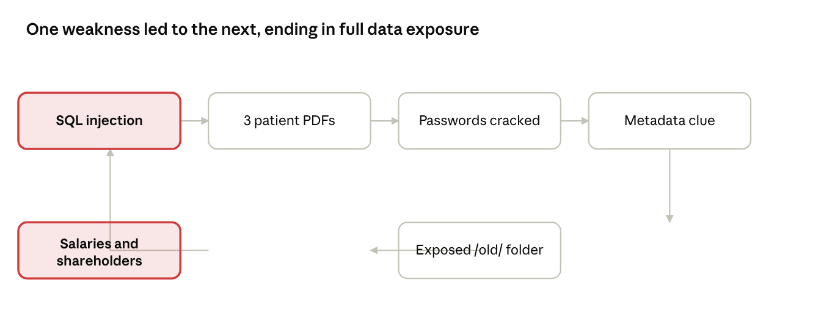
attack chain · SQL injection to full data exposure

3. Findings & Proof of Exploitation

Milestone 1 – Initial Access
Recon. curl https://medirozahospital.com/robots.txt revealed three hidden folders: /patient/, /staff/, /old/. The /patient/ folder held a login page at /patient/login.php.
Username enumeration. A fake username returned "Username not found", while admin returned "Incorrect password". The different messages confirm admin is a valid account (finding 1).
SQL injection. Entering admin' in the username field produced a MySQL syntax error, proving user input is placed directly into the database query (finding 2).
Login bypass. The payload admin' -- closed the query string and commented out the password check, logging in as admin with no valid password. The portal loaded with 3 reports, which I downloaded.

Milestone 2 – Cracking the Encryption
Each PDF's $pdf$ hash was extracted and run against a wordlist. Reports 1 and 2 fell to the 100-word built-in list; report 3 needed the larger rockyou wordlist via John the Ripper (finding 4).
File | Password | Wordlist
patient_report_1.pdf | 123456 | Built-in (100)
patient_report_2.pdf | password | Built-in (100)
patient_report_3.pdf | !@#$%^& | rockyou
Report 3 was then decrypted with qpdf to a clean copy for metadata analysis.

Milestone 3 – Deep Reconnaissance
Metadata. exiftool report3_open.pdf exposed two revealing fields (finding 5):
- Author: j.malik
- Comments: "DB backup moved to /old before site migration, do not delete"
Exposed backup. The /old/ folder (seen in robots.txt and now confirmed by the note) had directory listing enabled, exposing mediroza_db_backup_2019.sql (findings 6 and 7). I downloaded it with wget.
Completing the chain. The backup's staff table lists Jameel Malik, IT Systems Administrator (j.malik), the same person named in the PDF metadata who moved the backup and left the note. The trail is complete.

4. Confidential Data Exposed
The backup held two sensitive tables. National ID numbers, emails and phone numbers were also present but are redacted here in line with responsible handling of data uncovered during testing.

Staff salaries (monthly, ZAR) – 30 records
ID | Name | Job title | Department | Salary
1 | Dr. Rajesh Naidoo | Chief Pathologist | Diagnostics Lab | 138,000
2 | Sarah Botha | Chief Financial Officer | Finance | 152,000
3 | Dr. Johan van der Merwe | Medical Director | Management | 160,000
4 | Dr. Anita Naicker | Consultant Cardiologist | Cardiology | 132,000
5 | Dr. Ahmed Kara | Consultant Physician | Internal Medicine | 128,000
6 | Dr. Yusuf Cassim | Senior Registrar | Emergency & Trauma | 74,000
7 | Michael Roberts | HR Director | Human Resources | 96,000
8 | Susan Pretorius | HR Officer | Human Resources | 48,000
9 | Jameel Malik | IT Systems Administrator | IT | 58,000
10 | Thabo Molefe | Network Engineer | IT | 46,000
11 | Nomvula Khumalo | Registered Nurse | Emergency & Trauma | 34,000
12 | Lerato Mokoena | Registered Nurse | Pediatrics | 33,000
13 | Bongani Ndlovu | Registered Nurse | Cardiology | 35,000
14 | Zanele Mahlangu | Nursing Sister | Theatre | 42,000
15 | Kagiso Sithole | Pharmacist | Pharmacy | 61,000
16 | Naledi Zulu | Pharmacy Assistant | Pharmacy | 26,000
17 | Themba Nkosi | Radiographer | Radiology | 44,000
18 | Palesa Radebe | Radiographer | Radiology | 43,000
19 | Deepak Pillay | Lab Technologist | Diagnostics Lab | 41,000
20 | Kavitha Govender | Lab Technician | Diagnostics Lab | 35,000
21 | Dr. Suresh Moodley | Consultant Radiologist | Radiology | 130,000
22 | Dr. Fatima Patel | Pediatrician | Pediatrics | 118,000
23 | Nisha Singh | Physiotherapist | Rehabilitation | 48,000
24 | Dr. Vikram Chetty | Anaesthetist | Theatre | 135,000
25 | David Smith | Facilities Manager | Operations | 52,000
26 | Karen O'Connor | Billing Administrator | Finance | 29,000
27 | James Wilson | Security Supervisor | Operations | 27,000
28 | Linda Fourie | Receptionist | Front Office | 19,000
29 | Peter van Wyk | Procurement Officer | Supply Chain | 38,000
30 | Andile Mbeki | Ward Clerk | Administration | 21,000

Shareholders – 10 records
Shareholder | Share % | Shares held | Class
Dr. Rajesh Naidoo | 18.0 | 180,000 | Ordinary
Cedar Health Holdings (Pty) Ltd | 15.0 | 150,000 | Ordinary
Dr. Johan van der Merwe | 12.0 | 120,000 | Ordinary
Reddy Family Trust | 11.0 | 110,000 | Ordinary
Thabo Molefe | 10.0 | 100,000 | Ordinary
Sarah Botha | 9.0 | 90,000 | Ordinary
Dr. Ahmed Kara | 8.0 | 80,000 | Preferential
Naledi Zulu | 7.0 | 70,000 | Ordinary
Michael Roberts | 6.0 | 60,000 | Ordinary
Dr. Vikram Chetty | 4.0 | 40,000 | Preferential

5. Risk Rating
# | Vulnerability | Location | Risk
1 | Username enumeration via different error messages | /patient/login.php | Medium
2 | SQL injection login bypass | /patient/login.php | Critical
3 | Patient PDFs accessible after login bypass | /patient/ portal | High
4 | Weak PDF passwords (crackable with a wordlist) | patient_report_*.pdf | High
5 | Sensitive note left in PDF metadata | patient_report_3.pdf | Medium
6 | Directory listing enabled on a public folder | /old/ | Critical
7 | Database backup with salaries and shareholders exposed in plain text | /old/mediroza_db_backup_2019.sql | Critical

6. Recommendations & Remediation
- Fix the SQL injection (Critical). Use parameterised queries / prepared statements. Never build SQL from raw user input. This single fix closes the entry point for the whole chain.
- Remove the exposed backup (Critical). Delete or relocate mediroza_db_backup_2019.sql immediately, and never store database backups in a web-accessible folder.
- Disable directory listing (Critical). Turn off automatic indexing on all folders so file contents are not browsable.
- Stop username enumeration. Return one identical message for any failed login, regardless of which field is wrong.
- Protect patient files. Store them outside the web root or behind proper access control, and use a strong, unique password per file (not dictionary words).
- Strip metadata from all documents before distribution: exiftool -all= filename.pdf.
- Review the whole site for other instances of these patterns, and establish a routine to remove old files after migrations.

7. Conclusion & Evidence
This engagement showed how a chain of individually fixable weaknesses combined to expose the hospital's most sensitive data to an anonymous attacker. No step required advanced tooling; each exploited a basic misconfiguration or weak default. Fixing the SQL injection and removing the exposed backup are the two highest priorities.
All testing was confined to the authorised Networkwalks training environment.

EVIDENCE
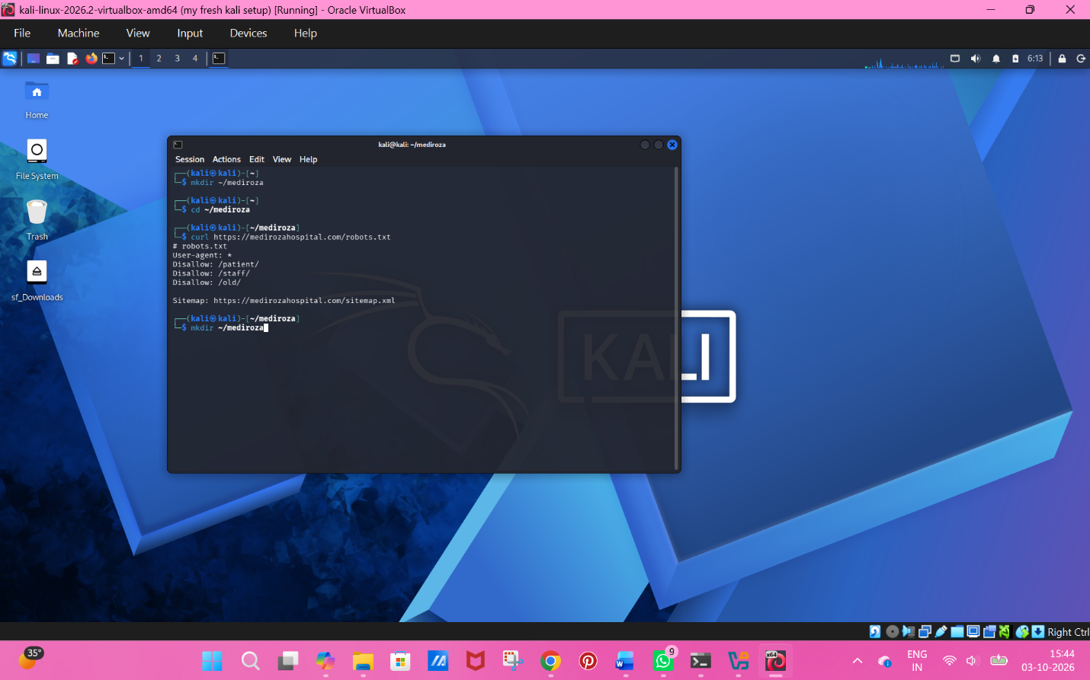
- robots.txt output showing the three hidden folders

- The MySQL error from admin' (SQL injection proof)

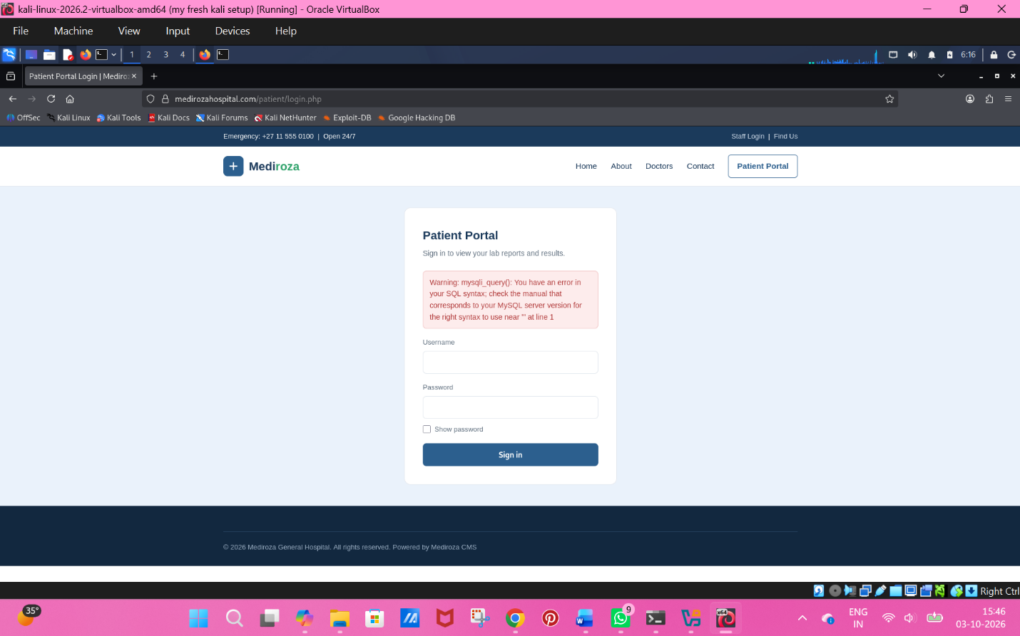

- The successful admin’ -- login and portal with 3 reports
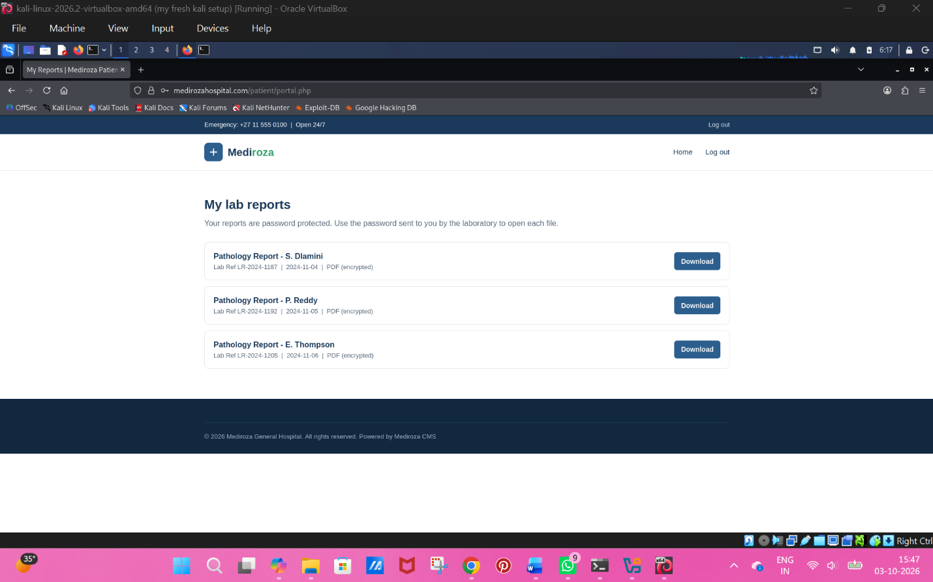

- The three cracked passwords (123456, password, !@#$%^&)

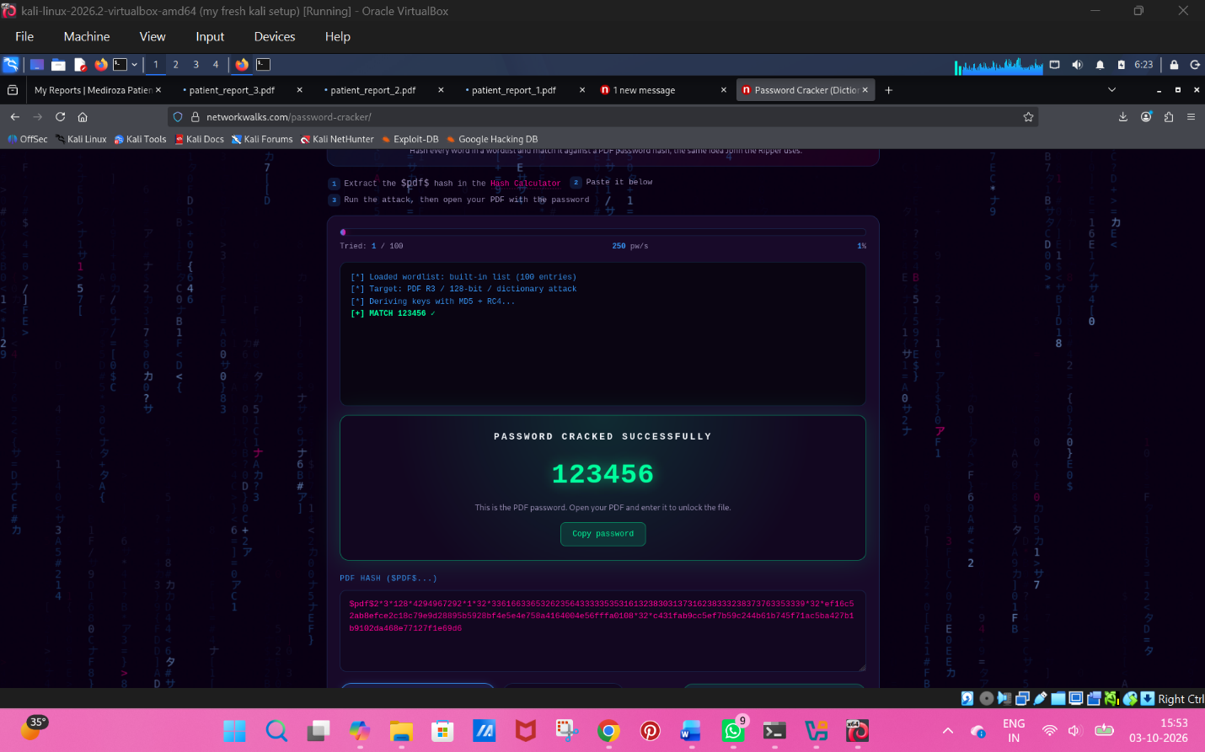

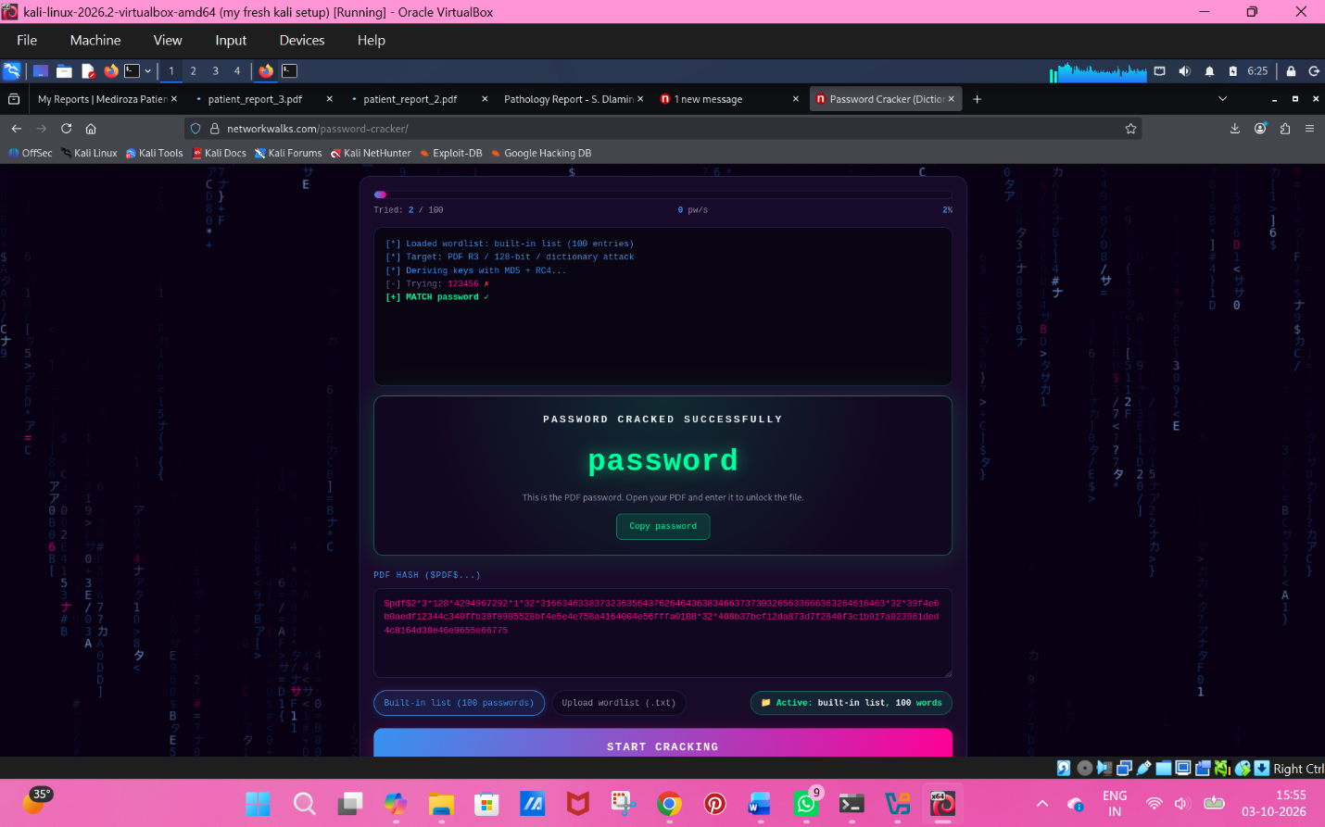

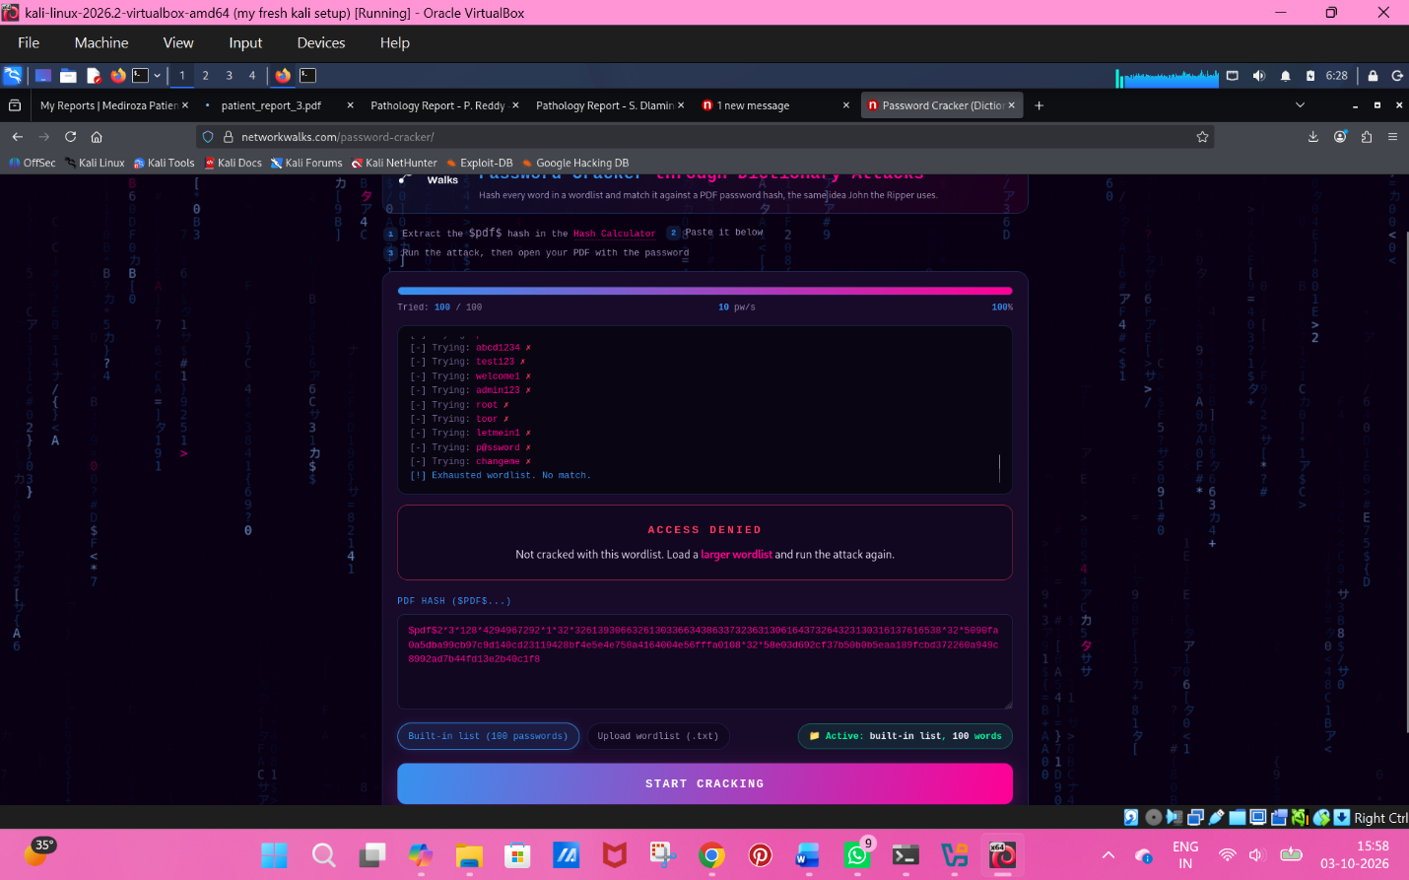

- exiftool output showing the Author and Comments fields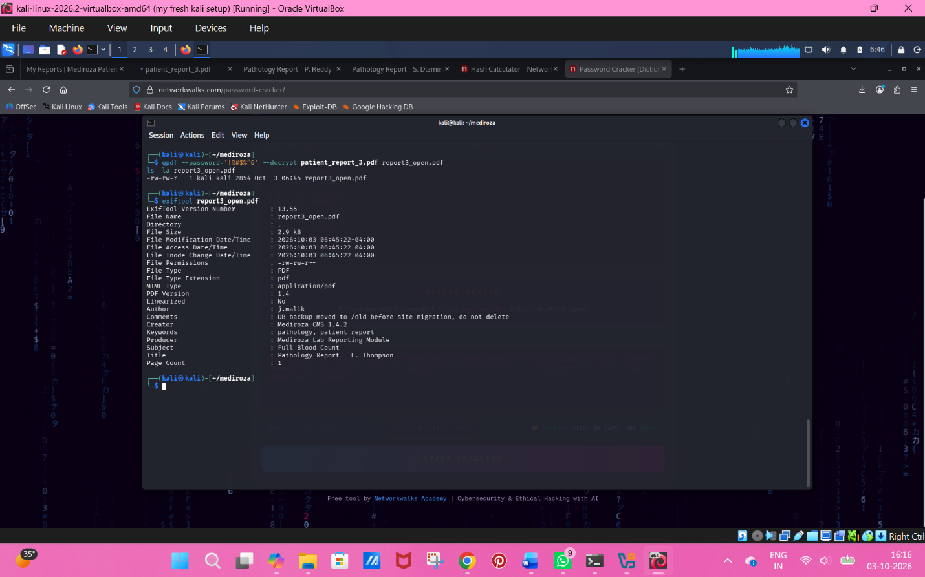

- The /old/ directory listing with the backup file
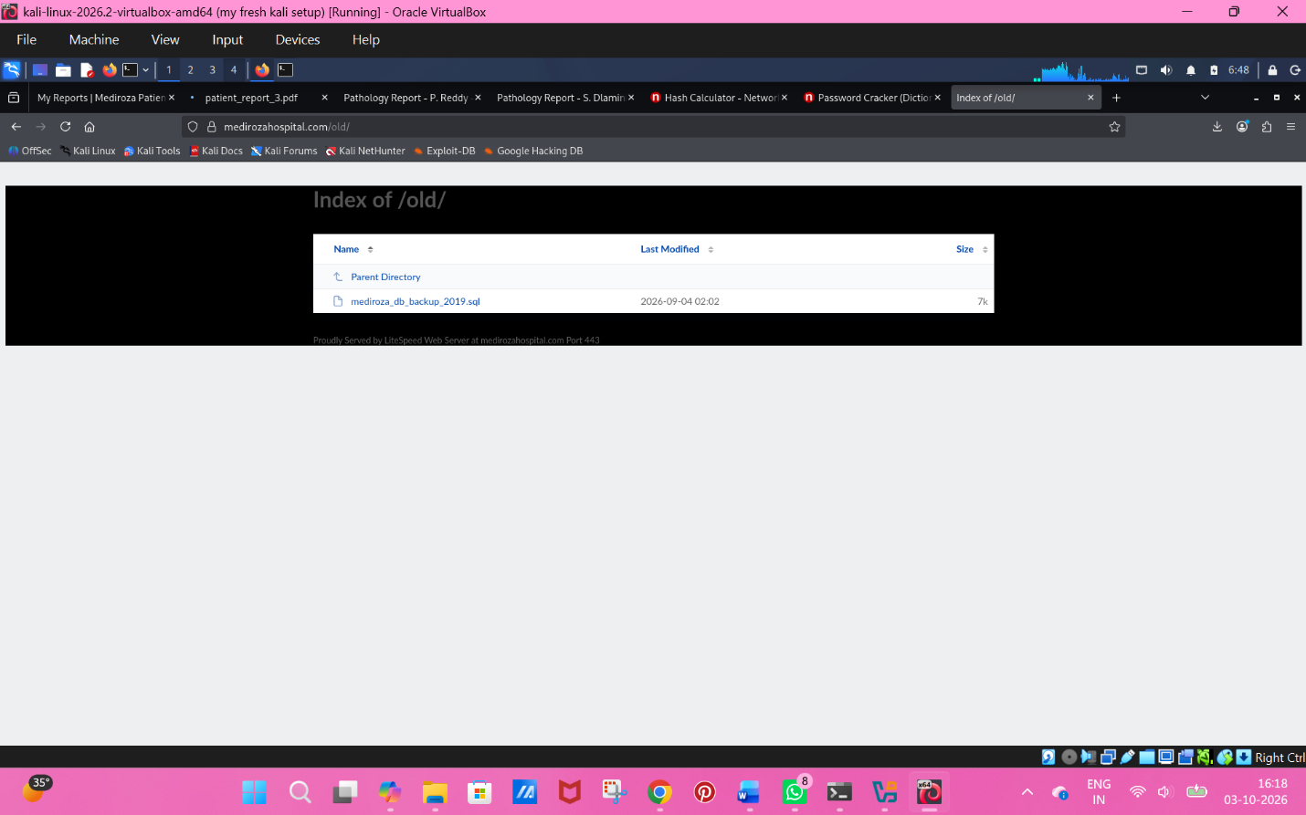

- ☐ The staff and shareholder data from the .sql backup (redact ID numbers)
